# Assignment 1: Basics of Python Programming

**Exercise 1**: Prime Numbers

Write a Python program that checks whether a given number is prime or not. A prime number is a natural number greater than 1 that has no positive divisors other than 1 and itself.

**Answer:**

Algorithm: -

1. Take an integer input from user.
2. Check whether the number entered by user is less than 2 or not.
3. If it is less than 2 then print entered number is not prime.
4. Else if the number is greater than 2 then run a loop that starts from 2 till the entered number square root.
5. If the number is divisible by the numbers in the range of the above loop, then the number entered is not a prime number.
6. Else the number entered is prime.

Code: -

num = int(input("Enter a number: "))

if num < 2:

print(num, "is not a prime number")

else:

for i in range(2, int(num ** 0.5) + 1):

if num % i == 0:

print(num, "is not a prime number")

break

else:

print(num, "is a prime number")

Screenshot: -

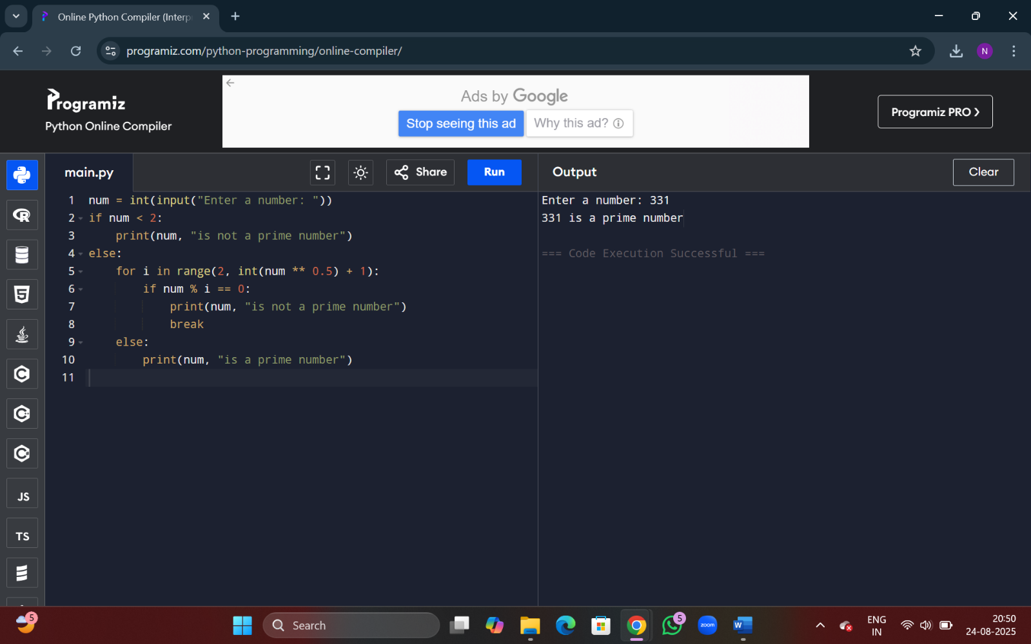

Exercise 2: Product of Random Numbers

Develop a Python program that generates two random numbers and asks the user to enter the product of these numbers. The program should then check if the user's answer is correct and display an appropriate message.

**Answer:**

Algorithm: -

1. Import module random to generate random integers.
2. Store the random numbers generated in two variables.
3. Display the numbers to user and ask user to enter the product of those numbers.
4. Calculate the product of the numbers generated and compare it with user value.
5. Use conditional statement to display appropriate message for right and wrong answer.

Code: -

import random

a = random.randint(1,100)

b = random.randint(1,100)

print("The numbers generated are ",a," and ",b)

user_res = int(input("Calculate the product and enter here: "))

def product_cal(a,b):

return a*b

comp_res = product_cal(a,b)

if user_res == comp_res:

print("You got the right answer!")

else:

print("WRONG!!!Try Again")

Screenshot: -

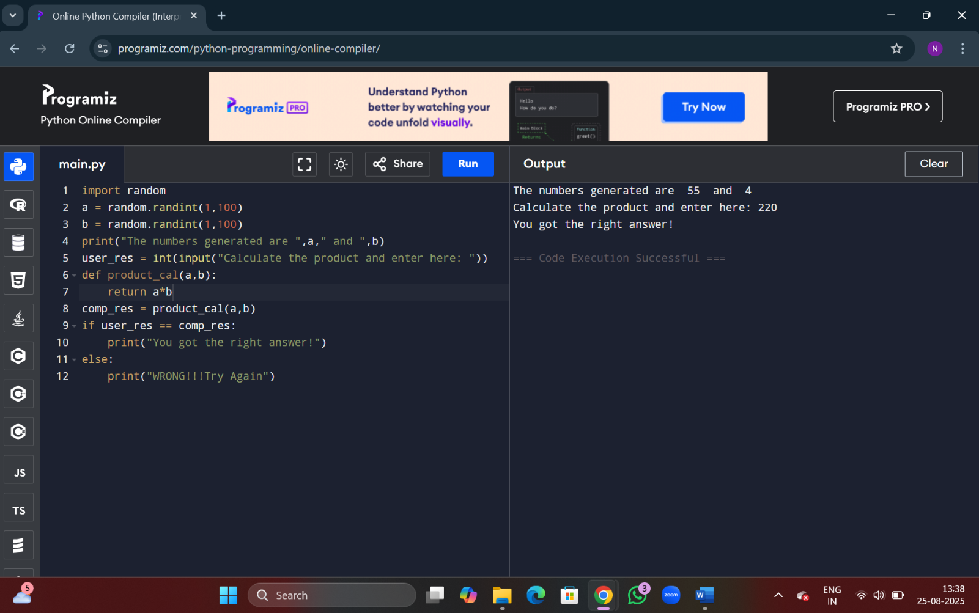

Exercise 3: Squares of Even/Odd Numbers

Create a Python script that prints the squares of all even or odd numbers within the range of 100 to 200. Choose either even or odd numbers and document your choice in the code.

**Answer:**

Algorithm: -

1. Use loop to have numbers in range of 100 to 200.
2. Use condition to determine the even numbers.
3. Calculate the square of all even numbers and display them.

Code: -

print("The square of all numbers in range 100 to 200 are displayed below:-")

for i in range(100,201):

if i % 2 == 0:

print("The square of ",i," is ",i*i)

Screenshot: -

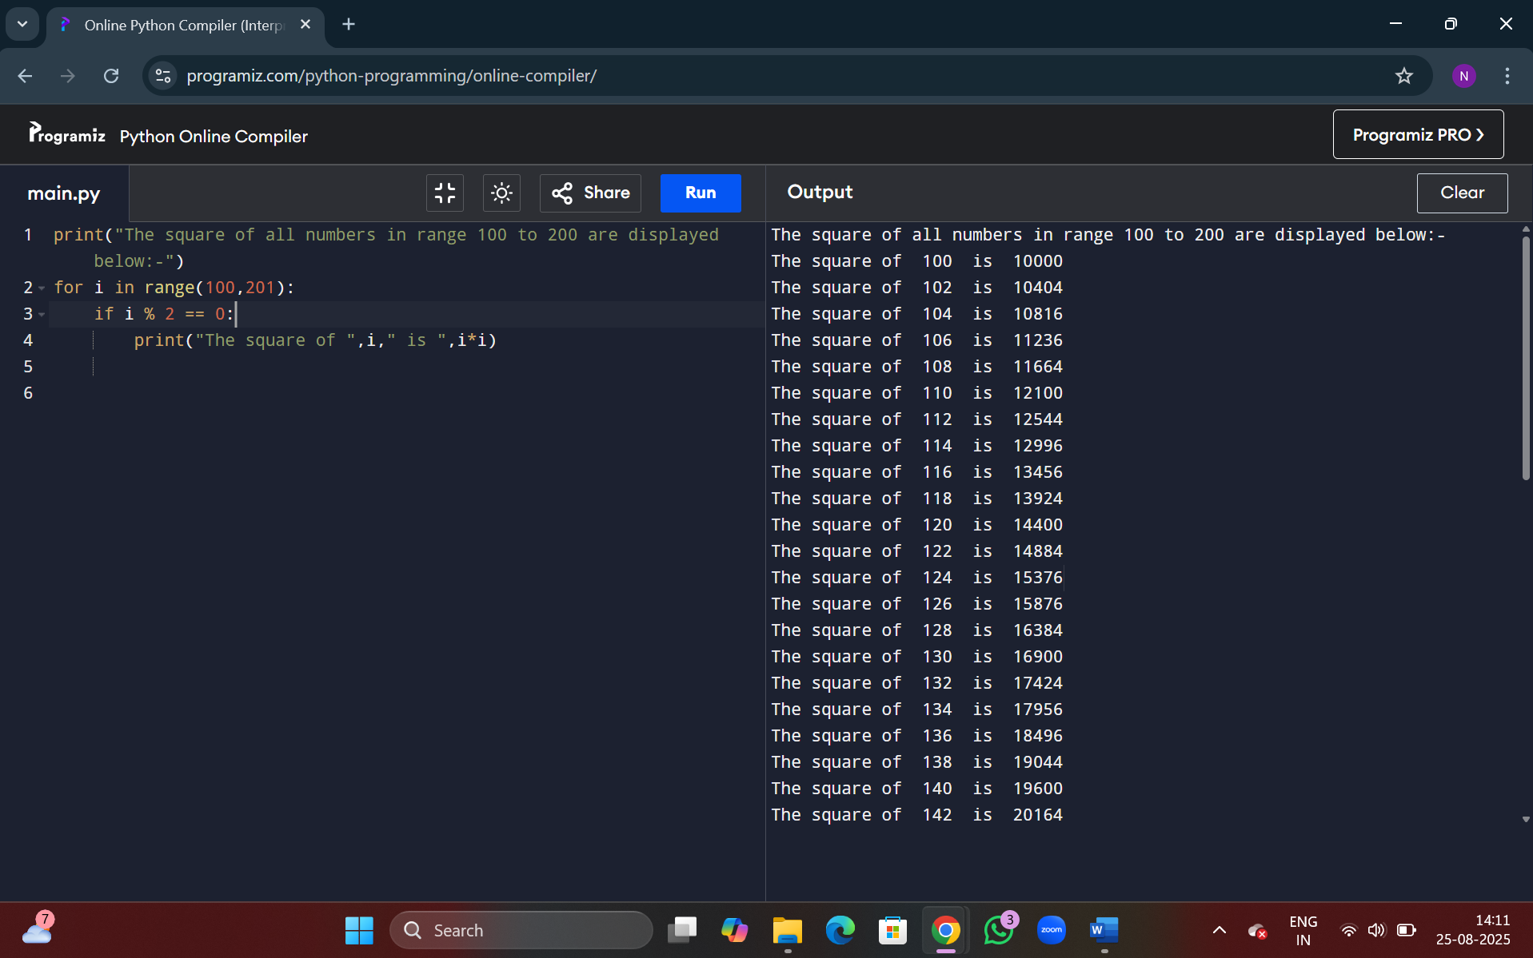

Exercise 4:

**✅ Problem Statement (Question): Hospital Billing System**

A hospital charges its patients based on the following:

* **Room charges per day**: ₹2,000
* **Doctor consultation fee (flat)**: ₹1,500
* **Lab test charges**: Based on the number of tests taken. Each test costs ₹300
* **Medicine charges**: Total cost of medicines provided
* **Discount**: If the total bill (before discount) exceeds ₹10,000, a 10% discount is applied

Write a Python program to calculate the **final bill** for a patient who:

* Stayed for **4 days**
* Had **3 lab tests**
* Had medicine charges of ₹2,400

**Answer:**

Algorithm: -

1. Store the charges of one day and one test in variables along with doctor consultation fees.
2. Take input from user for number of days, number of tests and medical charge.
3. Declare functions to calculate total room charge, total charge of lab tests, total bill.
4. Use conditional statement to check if the total bill exceeds 10000.
5. If exceeds apply 10% discount and print the result.

Code: -

room_charge = 2000

doctor_consult_fee = 1500

lab_test = 300

no_of_days = int(input("Enter number of days stayed in the hospital: "))

no_of_tests = int(input("Enter number of tests done in the hospital: "))

medical_charge = int(input("Enter medical charge: "))

def total_room_charge(no_of_days):

return room_charge*no_of_days

def total_test_charge(no_of_tests):

return lab_test*no_of_tests

def total_bill():

bill = doctor_consult_fee + medical_charge + total_room_charge(no_of_days) + total_test_charge(no_of_tests)

return bill

if total_bill() > 10000:

after_discount = total_bill() - (total_bill() * 0.1)

print("Your bill is after discount: ",after_discount)

else:

print("Your bill is: ",total_bill())

Screenshot: -

